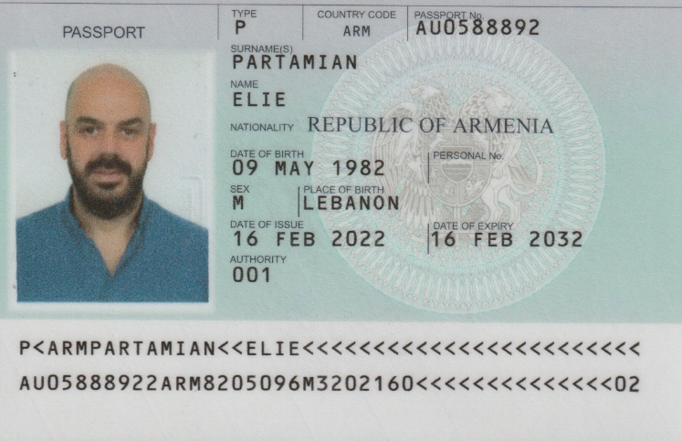
i3 International Onboarding & Acclimation Plan
Elie Partamian
Position: Business Development Manager
Territory: MEA
Department: Sales & Solutions Team
Start Date: Feb 20/2025
Flying in: Feb 20, 2026, to Toronto Canada
Staying at 77 Sylvan Ave. Scarborough, Ontario
Flying out Mar. 01, 2026
How Elie describes himself:
“

“

Welcome to i3 International
Welcome to i3 International, where our mission is to deliver affordable integrated AI solutions that improve safety, security, and operational efficiency for our clients. You’re joining a team rooted in family values, entrepreneurial spirit, and innovation—backed by 9 patents and over 35 years of success in the security technology space.

This onboarding plan is designed to help you build meaningful relationships, gain operational clarity, and understand how we approach technology and customer success. Over the next 4 weeks, you’ll be guided through an acclimation process customized to i3’s culture and your role.

By the end of the 4 weeks:
- You will have a clear plan co-created with your manager outlining the remainder of your probationary period.
- You will have a territory-specific sales plan to begin executing against your goals.
- Your support team—including mentors, sales engineers, and technicians—will assess the skills and knowledge needed for your success and guide you toward building the right toolkit for your assigned region or segment.

We’re excited to support you in this journey. Let’s get started. God speed . Aaron you will be fast tracking though this so you will have a condense 4-week onboarding period. With on of those weeks to be at the NSM training!

Partners and Mentors (please meet your support team and get their contact info)

Operational support
- Grace Baba – HR
- Operational fundamentals and tools – Mohit Sharma & Raj Patel
- Accounting – David Pan/Marilou Gutierrez
- Production – Kevin Enriquez
- IT Manager – Emmauel Navarro
- Technical Training: Olga Skelly and designated PM team member
- CMS – Greg Collins
- Sale Administration: Raj Patel, Mohit Sharma & Braeden Hoang
- Customer Success: Mylene Yaw

Sale and Marketing
- David Crook – Direct Manager
- Vy Hoang – Sale/business advisor
- Edward Chung – Marketing Manager

Mentors (please make sure they share their calendar with you)
- Hal Wever – Director of National Accounts – Named Account
- Paul Leiba – Business Development Manager - Grocery
- Paul Kerling – Sale Director
- George Karaolis – AVP of Business Development
- Brent Humprey – AVP of Business Development
- Jason Feltham - AVP of Business Development
- Steven Middleton – VP of Compliance

Program Objectives
- Build relationships across departments and understand team and company dynamics.
- Gain deep understanding of i3’s products, services, and platform.
  - Begin with reading the following books:
    - Grit - Angela Duckworth
    - Co-Intelligence – Ethan Mollick
    - Solution Selling – Michael T. Bosworth
- Learn our sales and solution process, from lead gen, onboarding to retention.
- Participate in mentor-led meetings and real-world customer interactions.
- Complete a 30-day business plan with personal KPIs and a SWOT summary.

Key Responsibilities for Support Teams

Manager Accountability
- Weekly 1:Training at Corporate Head Quarter, Toronto Canada
- Progress reviews and documentation
- Approving training logs and test completions
- Probationary period review and progress updates – this process will continue till your 6-month milestone
- Continuous checking and performance reviews on a weekly basis

Mentorship & Shadowing
- 2-3 mentor-led customer or partner meetings per mentor
- 2-3 internal team meetings (sales, support, project management)
- Submission of reflections and learning takeaways after each session

Acclimation Timeline (Please refer to excel training schedule for details).
Onboarding 30-90 schedule.xlsx
Week | Days | Focus
Week 1 | Days 1–5 | Sales and technical Training  Introduction to i3 culture, tools, and solutions. Setup access to systems (Salesforce, i3Host, Ai tools...). Meet your mentors and complete onboarding paperwork.  Product deep dive: Safety, Security, POS Analytics, Operational Tools. Attend tradeshow, shadow calls and document learnings.
Week 2 | Days 11–15 | Back to your home office and cultivating your Territory
Week 4 | Days 16–20 | Meet key team members (Marketing, Sales, Engineering, Support). Participate in technical overview meetings and join 1 sales-led pitch.
Week 5 | Days 21–25 | Executing your 30-day business strategy. Attend project management syncs. Start internal mock sales walkthrough.
Week 6 | Days 26–30 | Field activity or virtual client demo. Practice objection handling and feature/benefit storytelling. Get feedback from mentor.

After these six critical week you will be in control of your calendar and schedule accordingly to achieve your objectives and goals directed to you for your manager.

Key Evaluation & Tracking
Onboarding Tracking Sheet
Tracks learning modules, reflections, and mentor feedback. Please create a folder within one drive and share this with your manager, HR and Olga. This will be the folder where you will keep all your relevant documents, updates and forms.
 i3_onboarding_tracking_sheet.xlsx

Reflection Form Template
This will Includes:
- Key Learnings
- Questions Raised
- Summary of Meetings/Shadowing
- Areas to Revisit
- Suggestions for Improvement
 NEW HIRE REFLECTION FORM.docx (Olga will send this out)

Core Support Team
Role | Name | Responsibility
Direct Manager | David Crook/Vy | 1:1, performance oversight
Mentors | Please see below | Guided learning, reflection review
Sale | Vy Hoang & Mentors | Sale planning, insight and strategy
Technical | Olga Skelly and PM team | Technical deep dives
Marketing/Brand | Edward Chun and team | How marketing can help generate more leads for your through: Personal branding, social media, marketing programs
Business mindset | Mylene Law/Gregg Collin (CMS Team) | Real-world client insight and how our solutions are applied in their environment
Operational fundamentals | Mohit Sharma/Raj Patel | Admin support & onboarding logistics

Final Deliverables
- Complete training with reflection forms every Friday
- Share your calendar with your mentors and vice versa
- Attend 12-15 scheduled shadow meetings with mentors or your sale manager
- Demonstrate product knowledge in mock and live demo. These will be review and evaluated.
- Submit and present 30-day plan with SWOT to mentors and managers at 30-day completion of the onboarding process. Please this time and send out an invite to David and me. We will include others if required.

